Project Design Phase
Problem – Solution Fit Template

Date | 20 February 2026
Team ID | TVIP2026TMIDS41611
Project Name | OrderOnTheGo: Your On-Demand Food Ordering Solution
Maximum Marks | 2 Marks

Problem – Solution Fit :
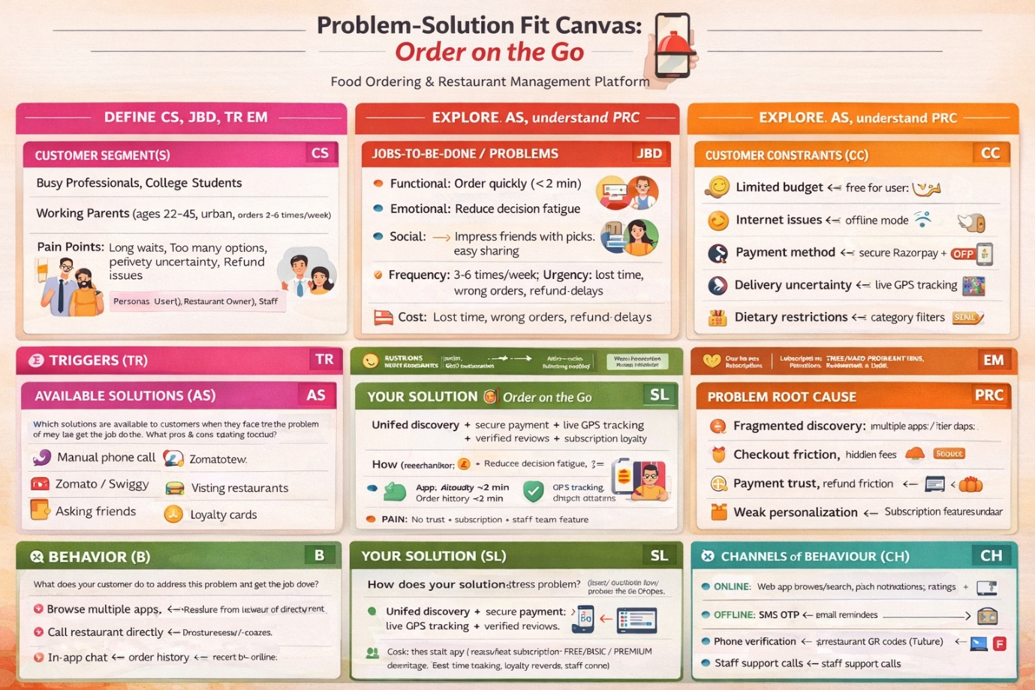

References:
- https://www.ideahackers.network/problem-solution-fit-canvas/
- https://medium.com/@epicantus/problem-solution-fit-canvas-aa3dd59cb4fe

